**1.** Write a program to read a length in inch scale and convert it in the centimeter scale.

**Code:**

import java.util.*;  
  
public class Main  
{  
 public static void main(String[] args)  
 {  
 Scanner input = new Scanner(System.in);  
  
 System.out.print("Length in Inches: ");  
 double lengthInInch = input.nextDouble();  
 double lengthInCenti = lengthInInch * 2.54;  
 System.out.println("Length in Centimeter: " + lengthInCenti);  
 }  
}

**Input - Output:**

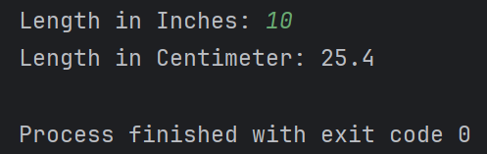

**2.** Write a program to convert a temperature reading in degree Fahrenheit to degree Celsius scale using the formula: C=(5/9)*(F-32)

**Code:**

import java.util.*;  
  
public class Main  
{  
 public static void main(String[] args)  
 {  
 Scanner input = new Scanner(System.*in*);  
  
 System.*out*.print("Temperature in Fahrenheit: ");  
 double tempInFar = input.nextDouble();  
 double tempInCel = (5 / 9.0) * (tempInFar - 32);  
 System.*out*.println("Temperature in Celsius: " + tempInCel);  
 }  
}

**Input - Output:**

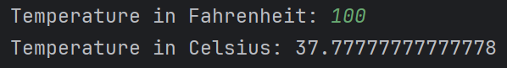

**3.** Write a program to read the radius of a circle and calculate its area and circumference.

**Code:**

import java.util.*;  
import java.lang.Math;  
  
public class Main  
{  
 public static void main(String[] args)  
 {  
 Scanner input = new Scanner(System.in);  
  
 System.out.print("Radius of a Circle: ");  
  
 int radius = input.nextInt();  
 double area = Math.PI * Math.pow(radius, 2);  
 double circumference = 2 * Math.PI * radius;  
  
 System.out.println("Area of The Circle: " + area);  
 System.out.println("Circumference of The Circle: " + circumference);  
 }  
}

**Input - Output:**

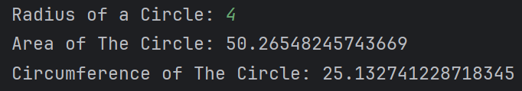

**4.** X, Y, Z are the marks of a student. Write a program to find the total and average marks of the student.

**Code:**

import java.util.*;  
public class Main  
{  
 public static void main(String[] args)  
 {  
 Scanner input = new Scanner(System.in);  
 int n, sum = 0;  
 System.out.print("Number of Subjects: ");  
 n = input.nextInt();  
 for (int i = 0; i < n; i++)  
 {  
 System.out.print("Subject "+(i+1)+":");  
 int temp = input.nextInt();  
 sum += temp;  
 }  
 System.out.println("Average: " + (double) sum / n + "/100.00");  
 }  
}

**Input - Output:**

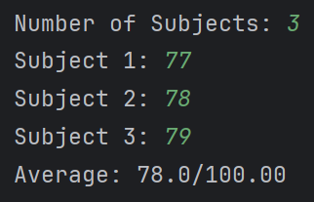

**5.** Write a program to compute the area of the triangle given the values of A, B and C. Area of a triangle is given by the formula Area = $√$ (S (S - A) (S - B) (S - C)) where A, B and C are the sides of a triangle and 2S = A + B + C.

**Code:**

import java.util.*;  
import java.lang.Math;  
  
public class Main  
{  
 public static void main(String[] args)  
 {  
 Scanner input = new Scanner(System.in);  
  
 int a = input.nextInt();  
 int b = input.nextInt();  
 int c = input.nextInt();  
  
 double s = (a + b + c) / 2.0;  
 double area = Math.sqrt(s*(s-a)*(s-b)*(s-c));  
 System.out.println("Area of The Triangle: "+area);  
 }  
}

**Input - Output:**

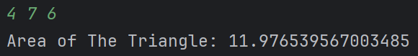

**6.** Evaluate the polynomial:

$$y=\left(\frac{x-1}{x}\right)+ \frac{{(\frac{x-1}{x})}^{2}}{2}+ \frac{{(\frac{x-1}{x})}^{3}}{3}+ \frac{{(\frac{x-1}{x})}^{4}}{4}$$

**Code:**

import java.util.*;  
import java.lang.Math;  
  
public class Main  
{  
 public static void main(String[] args)  
 {  
 Scanner input = new Scanner(System.*in*);  
 System.*out*.print("Value of x is: ");  
 int x = input.nextInt();  
 double y = 0;  
 for (int i = 1; i <= 4; i++)  
 y += Math.*pow*(((double) (x - 1) / x), i) / i;  
 System.*out*.println("Value of y is: " + y);  
 }  
}

**Input - Output:**

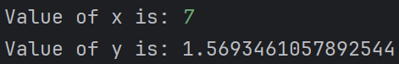

**7.** Write a program to calculate the roots of the quadratic equation ax2 + bx + c = 0 where a, b and c are known.

**Code:**

import java.util.*;  
import java.lang.Math;  
  
public class Main  
{  
 public static void main(String[] args)  
 {  
 Scanner input = new Scanner(System.*in*);  
 int a = input.nextInt();  
 int b = input.nextInt();  
 int c = input.nextInt();  
 double x1 = (-b + Math.*sqrt*((b * b) - (4.0 * a * c))) / (2.0 * a);  
 double x2 = (-b - Math.*sqrt*((b * b) - (4.0 * a * c))) / (2.0 * a);  
 System.*out*.println("x1 = " + x1);  
 System.*out*.println("x2 = " + x2);  
 }  
}

**Input - Output:**

